**Trends in Air Pollution in Ho Chi Minh City and the Associated Impact of Weather Conditions.**

**Written by:**

**Kevin Moroso – 098302599**

**Lien Pham – 100361334**

**Sarath Ravikumar – 100368894**

**Ayushi Singh – 100359100**

**March 28, 2021**

**Introduction**

Beginning in the 1980s, Vietnam has undergone tremendous economic growth, surpassing 5% growth annually in every year but one since 1990. This has been driven by industrialization, and Vietnam has become an export-oriented economy, becoming the 23rd largest economy in the world. This has also led to large increases in air pollution in Ho Chi Minh City, which contributes around 40% of Vietnam’s GDP, as a result of industrial and construction activities, as well as increases in vehicle ownership. The main drivers of air pollution in Ho Chi Minh City are transportation, especially due to older vehicles that do not comply with emissions standards, and construction, where the demolition of older buildings creating dust and the dispersal of cement powder when constructing new buildings.

The smog smothering Ho Chi Minh City is made of condensed air pollutants caused by high moisture and temperature inversion, which the municipal environment department says is “A combination of tropical convergence and cold air in the atmosphere [producing] cloudy sky in Ho Chi Minh City and high moisture levels, which [causes] air pollutants to condense into smog. As there was not enough sunlight to heat up the ground, temperature inversion kicked in and prevented the smog from being dispersed into the upper atmosphere, confining it close to the ground and making them thicker and longer-lasting.”[1]

Air pollution levels can be affected by a number of factors, both anthropogenic (e.g. vehicle emissions) and natural (e.g. direction and strength of wind), and can change throughout the year and over time. This paper focuses on four questions:

1. Is air quality in Ho Chi Minh City getting worse, improving, or staying the same?
2. How does air quality in Ho Chi Minh City change at different times of the year?
3. Is there a relationship between weather and air quality in Ho Chi Minh City?
4. Given the information gathered from questions 1 to 3, are there ways to mitigate the impact of air pollution in Ho Chi Minh City?

**Methodology**

To answer these 4 questions, a number of analyses were performed. In order to determine whether air quality in Ho Chi Minh City is getting worse, improving, or staying the same, air pollution data is compared for the month of December in each year from 2016 to 2020. In order to determine how air quality in Ho Chi Minh City changes at different times of the year, air pollution data is compared for the month of December 2020 to the month of February 2021. In order to determine whether there is a relationship between weather and air quality in Ho Chi Minh City, a variety of statistical tests were performed between air quality and humidity, temperature, precipitation, and wind speed.

The dataset created combines Raw Concentration pollution data and Air Quality Index (“AQI”) levels with humidity, temperature, precipitation, and wind speed for the month of December from 2016-2020, and 23 days in the month of February 2021.[2] Appendix A includes a description of the variables in the datasets*.*

The original dataset had outliers that were out of the expected range (“985” and negative values) and missing values (which had been replaced in the original dataset with “-999”) for Raw Concentration and AQI. This was cleaned by removing observations with missing air pollution data. Outliers beyond the expected range of a particular variable were also removed. Data was not replaced with medians or another number to ensure it didn’t affect relationship tests between air pollution and precipitation. The original dataset had 4224 observations before cleaning, 174 observations were removed during cleaning (4%), and 4050 observations remained after cleaning. As less than 5% of observations were removed, it should not significantly affect the analysis. Appendix B includes SAS and R codes for the combining and cleaning of the dataset.

**Section 1: Changes in Air Quality in Ho Chi Minh City (2016-2020)**

Air quality has changed in Ho Chi Minh City during the month of December over the 5-year period of 2016 to 2020. The analysis focuses on three different types of measurements: Raw Concentration levels, AQI levels, and AQI Categories. Raw concentration is the air pollution level of particulates 2.5 microns in diameter or smaller per cubic metre over a one hour period. NowCast is a weighted average of these hourly raw concentration observations from the most recent 12 hours but weighted more towards the more recent data and the AQI level is then derived from this. AQI categories are then based on the AQI levels. Formulas and tables that explain these variables further can be found in Appendix C. Appendix D includes the SAS codes for the analysis in this section.

**AQI Category Frequencies**

There are six AQI categories: Good, Moderate, Unhealthy for Sensitive Groups, Unhealthy, Very Unhealthy, and Hazardous. During the time period for the observations, there were no time periods that experienced air pollution levels of Very Unhealthy or Hazardous. This table and chart shows the frequency for each category within each month of December from 2016 to 2020.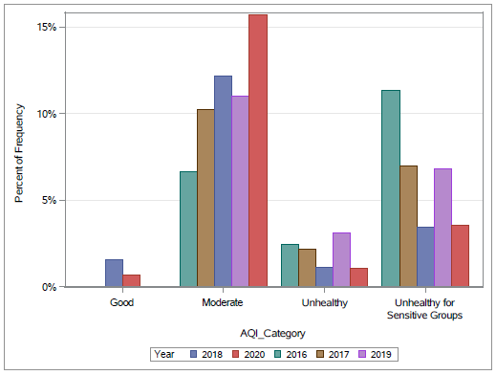

|  |  |  |  |  |  |
| --- | --- | --- | --- | --- | --- |
| **AQI Category** | **2016 - December** | **2017 - December** | **2018 - December** | **2019 - December** | **2020 - December** |
| **Good** | 0.00% | 0.00% | 8.55% | 0.00% | 3.26% |
| **Moderate** | 32.59% | 52.71% | 66.56% | 52.51% | 74.90% |
| ***Good and Moderate combined*** | ***32.59%*** | ***52.71%*** | ***75.11%*** | ***52.51%*** | ***78.16%*** |
| **Unhealthy for Sensitive Groups** | 55.57% | 36.02% | 18.66% | 32.56% | 16.82% |
| **Unhealthy** | 11.84% | 11.27% | 6.22% | 14.93% | 5.02% |
| ***Unhealthy and Unhealthy for Sensitive Groups combined*** | ***67.41%*** | ***47.29%*** | ***24.88%*** | ***47.49%*** | ***21.84%*** |

The proportion of time periods with air pollution that is unhealthy and unhealthy for sensitive groups displays a downward trend, with a high of 67.41% in 2016 (for both categories combined) to 21.84% in 2020, though this trend is not linear and has displayed significant variability in each month. Conversely, the proportion of time periods with air pollution levels that are good or moderate has increased. Even in the best year of December, 2020, air pollution levels are still unhealthy but this is a marked improvement from December 2016.

**AQI Changes**

AQI levels have also experienced change over this time period. These box plots show AQI levels data for the month of December in each year:

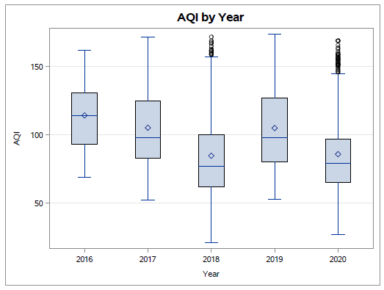

This table shows some summary statistics on AQI levels data:

|  |  |  |  |  |  |
| --- | --- | --- | --- | --- | --- |
|  | **2016 - December** | **2017 - December** | **2018 - December** | **2019 - December** | **2020 - December** |
| **Mean** | 114.31 | 105.28 | 84.71 | 105.05 | 85.84 |
| **Median** | 114 | 98 | 77 | 98 | 79 |
| **Minimum** | 69 | 52 | 21 | 53 | 27 |
| **Maximum** | 162 | 172 | 172 | 174 | 169 |
| **Standard Deviation** | 23.61 | 28.14 | 31.67 | 30.20 | 28.19 |
| **Range** | 93 | 120 | 151 | 121 | 142 |
| **Interquartile Range** | 38 | 42 | 38 | 47 | 32 |

Mean and median air pollution levels have declined from a high in 2016, reaching their lowest levels in 2018, rising again somewhat in 2019, before declining again in 2010. 2016 displays a more symmetric distribution, with the mean and median almost the same; 2017-2020, air pollution levels are skewed to the right (the mean is higher than the median) due to outliers of higher pollution levels. The box plots show a significant number of extreme outliers in 2018 and 2020, the two years with the lowest average AQI levels, showing that in years of lower average pollution, there are dramatic upswings in air pollution that are as high as years with higher average AQI levels.

The range in air pollution levels is increasing, with slight increases in the maximum range, but a significant decrease in the minimum levels of air pollution. There are more days of moderate and good levels of air pollution. Standard deviation has increased, from a low of 23.61 in 2016, peaking in 2018 at 31.67. This indicates that there is greater variability in air pollution levels; while air pollution may have declined, it is more erratic. However, the interquartile range displays no clear trend – it is the outliers that are causing greater variability; when these are removed, the range in air quality levels is more consistent over time. It should be noted that AQI levels are determined by the NowCast Concentration measure, and the NowCast Concentration measure is designed to smooth out some of the variability in the Raw Concentration measure.

Data from 2016 shows no discernible pattern in distribution, broadly spread out among categories of moderate and unhealthy for sensitive groups; data from 2017-2020 is skewed to the right, indicating most time periods have moderate air pollution, with a smaller number of days of higher, unhealthy levels of air pollution. Histograms displaying the frequencies of AQI levels can be found in Appendix E.

**Raw Concentration Changes**

Raw Concentration data provides real time pollution levels without any smoothing out of the variability that the AQI level calculations use. These box plots show Raw Concentration data for the month of December in each year: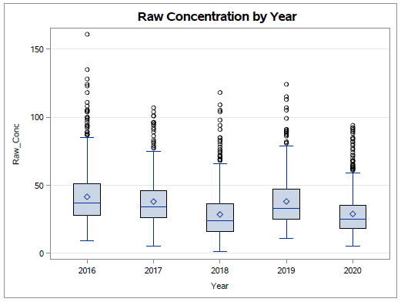

This table shows some summary statistics on AQI levels data:

|  |  |  |  |  |  |
| --- | --- | --- | --- | --- | --- |
|  | **2016 - December** | **2017 - December** | **2018 - December** | **2019 - December** | **2020 - December** |
| **Mean** | 41.35 | 37.85 | 28.32 | 37.97 | 28.74 |
| **Median** | 37 | 34 | 24 | 33 | 25 |
| **Minimum** | 9 | 5 | 1 | 11 | 5 |
| **Maximum** | 161 | 107 | 118 | 124 | 94 |
| **Standard Deviation** | 20.48 | 16.62 | 17.69 | 17.62 | 15.50 |
| **Range** | 152 | 102 | 117 | 113 | 89 |
| **Interquartile Range** | 23 | 20 | 20 | 22 | 17 |
| **Coefficient of Variation** | 49.52 | 43.91 | 62.45 | 46.40 | 53.93 |

The mean Raw Concentration levels are trending downwards, decreasing from 41.35 in 2016 down to 28.74 in 2020, though this is not a linear trend as they increased again in 2019. Median Raw Concentration levels show a similar trend, going from 37 in 2016 to 25 in 2020. The mean is higher than the median in every year, indicating air pollution levels are positively skewed – most times show moderate air pollution levels but there are a large number of outliers with higher levels of air pollution. There are more outliers of higher Raw Concentration levels than shown in the AQI levels, as AQI levels are designed to smooth out some of the variability.

Minimum levels of air pollution have not significantly changed, whereas maximum levels of air pollution have declined significantly – from a peak of 161 in 2016 to a maximum level of only 94 in 2020, the lowest levels in the 5 year period. Correspondingly, the range has therefore declined, from 152 in 2016 to 89 in 2020. The standard deviation has also shown a moderate decline, from a high of 20.48 in 2016, to a low of 15.50 in 2020 – confirming less variability in air pollution levels. The interquartile range has also declined from a peak of 23 in 2016 to 17 in 2020; so even when outliers are excluded, there is less variability in air pollution levels.

The distribution of Raw Concentration data is similar for all years, being positively skewed to the right. This means that the outliers are for high levels of pollution and Raw Concentration levels are more concentrated at lower levels. Histograms displaying the frequencies of Raw Concentration levels can be found in Appendix E.

**Conclusion**

While air pollution levels in Ho Chi Minh City have significantly increased over the decades since the rapid industrialization of Vietnam, the trend seems to have reversed over the last 5 years, from a high in 2016 to a low in 2020. There is also less variability in air pollution levels, with fewer time periods of extreme and high levels. This is likely due to concerted action on the part of local authorities to reduce reliance on private vehicles, encouraging people to use public transport, and reducing congestion by varying working and school hours.[3] However, with air pollution levels that are unhealthy or unhealthy for sensitive groups around one-fifth of the time, levels are still quite high and will continue to affect people’s health.

**Section 2: Difference in Air Quality in Ho Chi Minh City (February vs December)**

The next analysis focuses on examining the difference in air pollution levels between December 2020 and February 2021[4], focusing again on AQI and Raw Concentration levels. SAS codes for this analysis can be found in Appendix F.

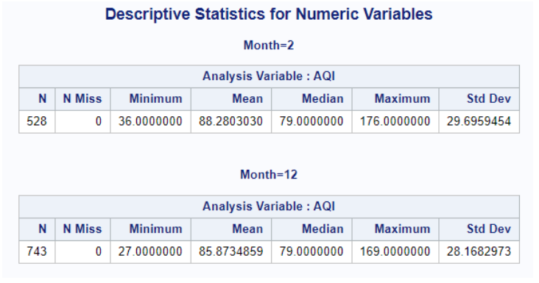**AQI Changes**

The table above displays summary statistics for AQI levels in February 2021 and then December 2020. Average AQI levels are somewhat higher in the month of February (88.28) than in December (85.87), and both the minimum and maximum levels of air pollution are higher in February. However, this is due to outliers in February as the median AQI levels are the same in both months at 79. This box plot shows the similarities in pollution levels in both months:

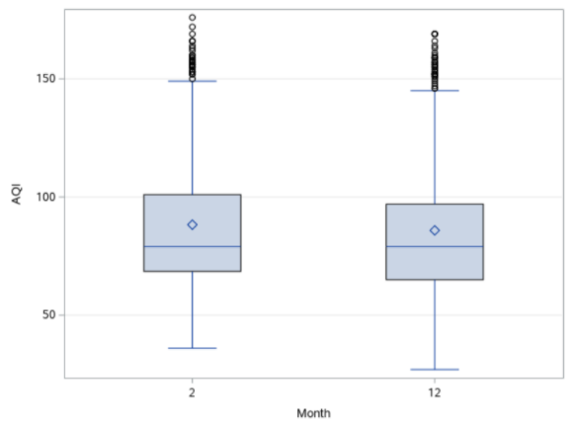

**AQI Category Frequencies**

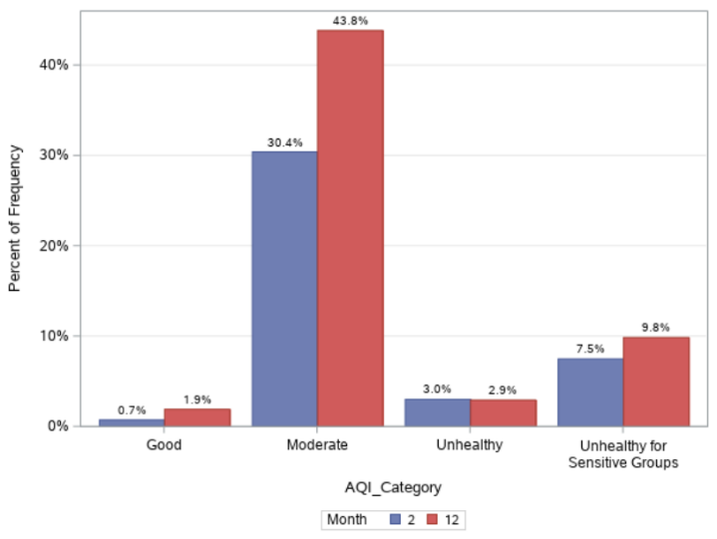Focusing on the AQI categories for the two months, there are only some slight differences in air quality:

Neither February nor December had any time periods with air pollution levels that were Very Unhealthy or Hazardous. December has more time periods of good air quality (3.23%) than in February (1.70%) but a similar number of time periods that are moderate, with air quality being moderate 74.97% of the time in December, and 73.11% of the time in February. February had more time periods of Unhealthy (7.20%) or Unhealthy for Sensitive Groups (17.99%), than December (4.98% and 16.82% respectively).

**Raw Concentration Changes**

Raw Concentration levels were also analyzed as AQI levels are designed to smooth out some of the variability in air pollution levels.

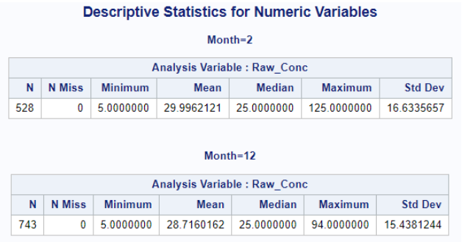Both February and December have similar minimum levels of air pollution (5.0) but maximum levels in February are far higher at 125.0 when compared to December at 94.0 – February can have more dramatic swings upwards in air pollution levels. Despite these higher levels in February, median levels of air pollution are the same for each month (25.0) and average levels in February are only moderately higher at 30.0 when compared to December at 28.7. The boxplot below displays these similarities in air pollution levels in both months, with the exception of the 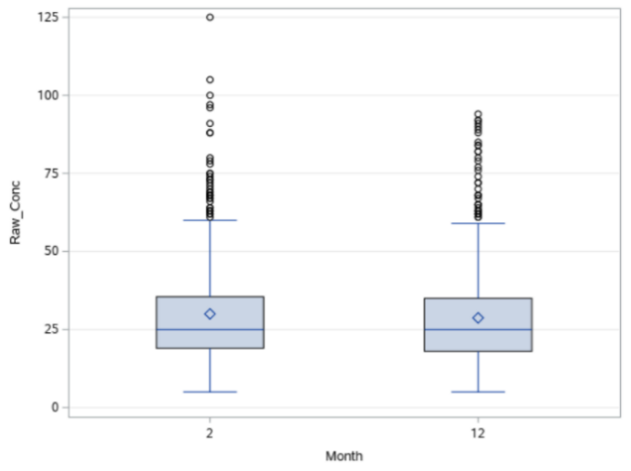outliers of higher air pollution levels in February:

**Conclusion**

February 2021 had only slightly higher levels of air pollution than in December 2020. One might expect to see significantly higher levels in February, due to the Tet festival during that time period which usually experiences high levels of travel, tourism, and the use of fireworks and firecrackers. However, due to the COVID-19 pandemic, these activities were largely curtailed in 2021, reducing the potential impact they have on air pollution levels.

**Section 3: Relationship between Air Quality and Weather in Ho Chi Minh City**

Weather can have a big impact on air quality, either suppressing or elevating pollution levels caused by man-made factors such as transportation and construction. In this section, we focus on the months included in previous sections, the months of December in 2016 through 2020, and the month of February 2021. Correlation methods were used for numeric and categorical variables to examine any relationship. A linear regression model was developed, using weather data with a 3- and 7-day time lag from air pollution data as it takes time for weather to impact air quality. In the linear regression model, we also examine the interactive impact of two continuous variables/pairs on the dependent variable by multiplying these two variables with each other. A chi-square test was used to measure the relationship among categorical variables. R Codes for this section can be found in Appendix G.

**Preliminary analysis**

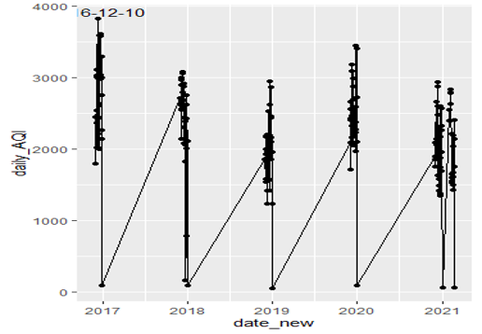Before examining the relationship between the different variables, differences in air pollution between weekdays and weekends were examined. The primary drivers of air pollution, such as construction and transport, are higher on weekdays. However, pollution levels would therefore be expected to accumulate throughout the weekdays and carry over into the weekend. This scatterplot displays AQI levels for weekends:

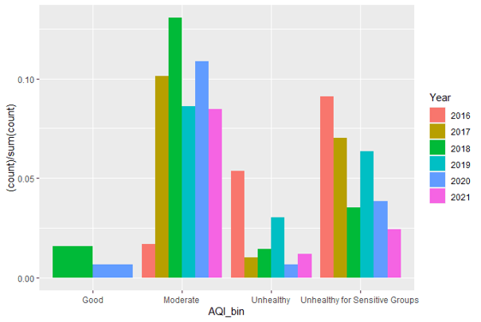And this bar chart displays the frequency of AQI categories for weekends:

As the graphs above show, there are high levels of air pollution on weekends:

* For December 2018, the majority of time periods have an AQI of Moderate;
* December 2016 has the highest frequency of time periods where the AQI is Unhealthy for Sensitive Groups;
* December 2019 has the highest frequency of time periods where the AQI is Unhealthy;
* The frequency of time periods in December 2020 where the AQI is Unhealthy is even higher than December for all weekend days;
* Years 2018 and 2020 have the highest frequency of time periods where the AQI is Moderate.

There are a total of 1195 observations for weekend days in all years; 573 of these observations have an AQI that is Unhealthy or Unhealthy for Sensitive Groups, 49% of the total. This is a larger proportion than found in Sections 1 and 2. Therefore, we can conclude that the pollution is worse on weekends, despite the fact that construction and transportation activities are reduced on those days, and supporting the approach taken to examine time lags when examining the relationship between weather and air pollution.

From above graphs, we also see that there are some days in 2017 and 2020 that have extremely high AQI levels. Interestingly, some of the days are during the weekend:

* 10 December 2016 (Total AQI over 24 hours: 3823; average hourly AQI: 159)
* 22 December 2019 (Total AQI over 24 hours: 2571; average hourly AQI: 108)

**Correlation**

Correlations were performed among all of the numerical variables. The following table shows the variables that had the highest correlations:

|  |  |
| --- | --- |
| **Variables** | **R number** |
| Humidity & Temperature (Celsius) | -0.76 |
| Humidity & Heat Index (Celsius) | -0.65 |
| AQI & Wind speed | -0.24 |
| Humidity and Wind speed | -0.19 |
| Heat Index (Celsius) and AQI | 0.14 |
| Temperature (Celsius) & AQI | 0.12 |

Using this method, the correlations were weak for each pair of variables. Therefore, we transformed some of the numerical variables above into categorical variables. Wind speed, precipitation, and humidity display skewed distributions, which means that a binning technique will not work as too many observations will be in low or high groups. Therefore, the data distribution itself decides bin ranges with no manual intervention as the bins will contain a uniform number of data points. The variables were divided by quantile to produce equal numbers for each group: Low, Medium, High. This method helps in partitioning the continuous valued distribution of a specific numeric field into discrete contiguous bins or intervals. Histograms displaying the distribution of the variables, along with an example of the binning technique, can be found in Appendix H.

|  |  |  |  |
| --- | --- | --- | --- |
| **Pairs** | **CramerV (Categorical variables)** | **Pairs** | **Correlation**  **(Numeric variables)** |
| AQI & Wind speed | 0.1165437 | AQI & Wind speed | -0.24 |
| AQI & Weather [condition] | 0.1334249 | AQI & Heat Index | 0.14 |
| AQI & Precipitation | 0.03355126 | AQI & Precipitation | 0.0078 |
| AQI & Temperature | 0.1015877 | AQI & Temperature | 0.12 |
| AQI & Humidity | 0.09740825 | AQI & Humidity | -0.76 |

Two pairs of variables, AQI & Wind speed and AQI & Humidity, are negatively correlated using both the CramerV method and the correlation method. The CramerV method shows AQI increasing when wind speed decreases; low wind speed is related to higher levels of air pollution. Using the correlation method, two variables (AQI & Wind Speed) increase relatively with each other. AQI & Weather [Condition] and AQI & Temperature show the same results with both methods; when one increases then another will slightly increase.

**Linear regression**

Eight different linear regression models were developed to examine, with AQI as the dependent variable in each of them.

*Model 1: AQI as dependent variable; Temperature, Humidity, Wind speed and Precipitation as predictors or independent variables*

|  |
| --- |
| Residuals:  Min 1Q Median 3Q Max  -71.322 -22.257 -5.562 20.467 77.324  Coefficients:  Estimate Std. Error t value Pr(>|t|)  (Intercept) 84.1424 11.1285 7.561 4.91e-14 ***  tempC 1.1901 0.2553 4.662 3.23e-06 ***  humidity -0.0258 0.0624 -0.413 0.679  precipMM 2.2593 1.7456 1.294 0.196  windspeedKmph -2.1733 0.1381 -15.738 < 2e-16 ***  ---  Signif. codes: 0 ‘***’ 0.001 ‘**’ 0.01 ‘*’ 0.05 ‘.’ 0.1 ‘ ’ 1  Residual standard error: 29.66 on 4072 degrees of freedom  Multiple R-squared: 0.07656, Adjusted R-squared: 0.07565  F-statistic: 84.4 on 4 and 4072 DF, p-value: < 2.2e-16 |

The R-square for Model 1 is quite low at 7.6%, meaning the model can only explain 7.6% the variability of AQI. Temperature, wind speed, and humidity are statistically significant with a confidence interval of approximately 99%. Temperature has a coefficient of 1.19 which means if temperature increases by 1 degree, AQI levels will increase by 1.19. Wind speed has a coefficient of -2.17 which means if wind speed increases by 1 km/h, AQI levels will decrease by -2.17.

*Model 2: AQI as dependent variable; Temperature alone as an independent variable*

|  |
| --- |
| Residuals:  Min 1Q Median 3Q Max  -75.93 -23.22 -6.01 21.56 76.78  Coefficients:  Estimate Std. Error t value Pr(>|t|)  (Intercept) 64.8932 4.1845 15.508 < 2e-16 ***  tempC 1.2132 0.1533 7.912 3.23e-15 ***  ---  Signif. codes: 0 ‘***’ 0.001 ‘**’ 0.01 ‘*’ 0.05 ‘.’ 0.1 ‘ ’ 1  Residual standard error: 30.58 on 4047 degrees of freedom  Multiple R-squared: **0.01523**, Adjusted R-squared: 0.01499  F-statistic: 62.6 on 1 and 4047 DF, p-value: 3.235e-15 |

*Model 3: AQI as dependent variable; Humidity alone is an independent variable*

|  |
| --- |
| Residuals:  Min 1Q Median 3Q Max  -75.842 -23.212 -6.224 21.282 75.675  Coefficients:  Estimate Std. Error t value Pr(>|t|)  (Intercept) 106.48300 2.62242 40.605 < 2e-16 ***  humidity -0.12361 0.03662 -3.375 0.000745 ***  Signif. codes: 0 ‘***’ 0.001 ‘**’ 0.01 ‘*’ 0.05 ‘.’ 0.1 ‘ ’ 1  Residual standard error: 30.77 on 4047 degrees of freedom  Multiple R-squared: **0.002807,** Adjusted R-squared: 0.002561  F-statistic: 11.39 on 1 and 4047 DF, p-value: 0.0007446 |

*Model 4: AQI as dependent variable; Humidity alone is an independent variable*

|  |
| --- |
| Residuals:  Min 1Q Median 3Q Max  -74.326 -22.639 -6.326 20.256 80.674  Coefficients:  Estimate Std. Error t value Pr(>|t|)  (Intercept) 114.2672 1.1387 100.35 <2e-16 ***  windspeedKmph -2.1046 0.1324 -15.89 <2e-16 ***  ---  Signif. codes: 0 ‘***’ 0.001 ‘**’ 0.01 ‘*’ 0.05 ‘.’ 0.1 ‘ ’ 1  Residual standard error: 29.89 on 4047 degrees of freedom  Multiple R-squared: **0.05874**, Adjusted R-squared: 0.05851  F-statistic: 252.6 on 1 and 4047 DF, p-value: < 2.2e-16 |

Models 2, 3, and 4 each use a single predictor for AQI levels, Temperature, Humidity, and Wind speed. Each has an even lower R-square than Model 1 when we examined all the predictors/ independent variables together:

* Model 2 (AQI ~ Temperature): R-square: 1.5%
* Model 3 (AQI ~ Humidity): R-square: 0.28%
* Model 4(AQI ~ Wind speed): R-square: 5.8%

None of these predictor variables display a significant relationship to AQI levels. The next two models used a time lag to examine the relationship between weather and AQI levels.

*Model 5: AQI as dependent variable; Temperature, Humidity, Wind speed and Precipitation as predictors or independent variables. 3-day time lag*

|  |
| --- |
| Residuals:  Min 1Q Median 3Q Max  -70.301 -21.099 -4.696 19.414 88.255  Coefficients:  Estimate Std. Error t value Pr(>|t|)  (Intercept) 136.181081 10.890905 12.504 <2e-16 ***  tempC -0.598544 0.249720 -2.397 0.0166 *  humidity 0.005723 0.061085 0.094 0.9254  precipMM 3.142195 1.705996 1.842 0.0656 .  windspeedKmph -2.909917 0.135499 -21.476 <2e-16 ***  ---  Signif. codes: 0 ‘***’ 0.001 ‘**’ 0.01 ‘*’ 0.05 ‘.’ 0.1 ‘ ’ 1  Residual standard error: 28.98 on 4041 degrees of freedom  (3 observations deleted due to missingness)  **Multiple R-squared: 0.1169**, Adjusted R-squared: 0.1161  F-statistic: 133.8 on 4 and 4041 DF, p-value: < 2.2e-16 |

*Model 6: AQI as dependent variable; Temperature, Humidity, Wind speed and Precipitation as predictors or independent variables. 7-day time lag*

|  |
| --- |
| Residuals:  Min 1Q Median 3Q Max  -68.234 -20.622 -2.635 18.197 87.731  Coefficients:  Estimate Std. Error t value Pr(>|t|)  (Intercept) 152.30746 10.48916 14.520 < 2e-16 ***  tempC -1.61908 0.24044 -6.734 1.89e-11 ***  humidity 0.18047 0.05881 3.069 0.00216 **  precipMM 1.22642 1.64152 0.747 0.45503  windspeedKmph -2.99200 0.13087 -22.862 < 2e-16 ***  ---  Signif. codes: 0 ‘***’ 0.001 ‘**’ 0.01 ‘*’ 0.05 ‘.’ 0.1 ‘ ’ 1  Residual standard error: 27.87 on 4037 degrees of freedom  (7 observations deleted due to missingness)  **Multiple R-squared: 0.1835**, Adjusted R-squared: 0.1827  F-statistic: 226.8 on 4 and 4037 DF, p-value: < 2.2e-16 |

Models 5 and 6 provided better R-square results. Using a 3-day time lag for the predictor variables explained 12% of AQI levels; using a 7-day time lag for the predictor variables explained 18% of AQI levels. The adjusted R-squared also increased from 11% for Model 5 to 18% for Model 6. Temperature, Wind speed, and Humidity are statistically significant with a confidence interval of approximately 99%. Temperature has a coefficient of -1.6, which means that if temperature increases 1 degree Celsius, the AQI levels will decrease by 1.6. Humidity has a coefficient of 0.18, which means that if humidity increases by 1 unit, AQI levels will increase by 0.18. Wind speed has a coefficient of -2.99, which means that if wind speed increases by 1km/hr, AQI levels will decrease by 2.99.

*Model 7: AQI as dependent variable; Temperature, Humidity, Wind speed and Precipitation as predictors or independent variables; TempC*windspeedKmph , tempC*humidity , tempC*precipMM are also independent variables*

|  |
| --- |
| Residuals:  Min 1Q Median 3Q Max  -70.672 -20.215 -3.091 18.141 89.160  Coefficients:  Estimate Std. Error t value Pr(>|t|)  (Intercept) 161.71786 26.13985 6.187 6.76e-10 ***  tempC -1.82083 0.87661 -2.077 0.037852 *  humidity 1.07419 0.31216 3.441 0.000585 ***  precipMM -35.68322 18.11143 -1.970 0.048883 *  windspeedKmph -10.12353 1.16270 -8.707 < 2e-16 ***  tempC:windspeedKmph 0.26310 0.04219 6.236 4.94e-10 ***  tempC:humidity -0.03573 0.01118 -3.197 0.001400 **  tempC:precipMM 1.39842 0.64976 2.152 0.031439 *  ---  Signif. codes: 0 ‘***’ 0.001 ‘**’ 0.01 ‘*’ 0.05 ‘.’ 0.1 ‘ ’ 1  Residual standard error: 27.68 on 4034 degrees of freedom  (7 observations deleted due to missingness)  **Multiple R-squared: 0.1952**, Adjusted R-squared: 0.1938  F-statistic: 139.8 on 7 and 4034 DF, p-value: < 2.2e-16 |

*Model 8 : AQI as dependent variable; Temperature, Humidity, Wind speed and Precipitation as predictors or independent variables; tempC*windspeedKmph , tempC*humidity , tempC*precipMM, humidity * precipMM, humidity * windspeedKmph,precipMM * windspeedKmph are also independent variables*

|  |
| --- |
| Residuals:  Min 1Q Median 3Q Max  -77.447 -20.224 -3.228 18.208 80.431  Coefficients:  Estimate Std. Error t value Pr(>|t|)  (Intercept) 1.828e+02 3.578e+01 5.110 3.37e-07 ***  tempC -2.324e+00 1.029e+00 -2.259 0.02395 *  humidity 8.919e-01 3.551e-01 2.512 0.01206 *  precipMM -2.364e+02 8.943e+01 -2.644 0.00823 **  windspeedKmph -1.152e+01 2.667e+00 -4.319 1.60e-05 ***  tempC:windspeedKmph 2.863e-01 6.457e-02 4.434 9.48e-06 ***  tempC:humidity -3.183e-02 1.120e-02 -2.841 0.00452 **  tempC:precipMM 5.903e+00 1.914e+00 3.083 0.00206 **  humidity:precipMM 6.026e-01 4.765e-01 1.265 0.20609  humidity:windspeedKmph 7.845e-03 1.553e-02 0.505 0.61344  precipMM:windspeedKmph 3.176e+00 5.318e-01 5.972 2.54e-09 ***  ---  Signif. codes: 0 ‘***’ 0.001 ‘**’ 0.01 ‘*’ 0.05 ‘.’ 0.1 ‘ ’ 1  Residual standard error: 27.55 on 4031 degrees of freedom  (7 observations deleted due to missingness)  **Multiple R-squared: 0.2036,** Adjusted R-squared: 0.2016  F-statistic: 103 on 10 and 4031 DF, p-value: < 2.2e-16 |

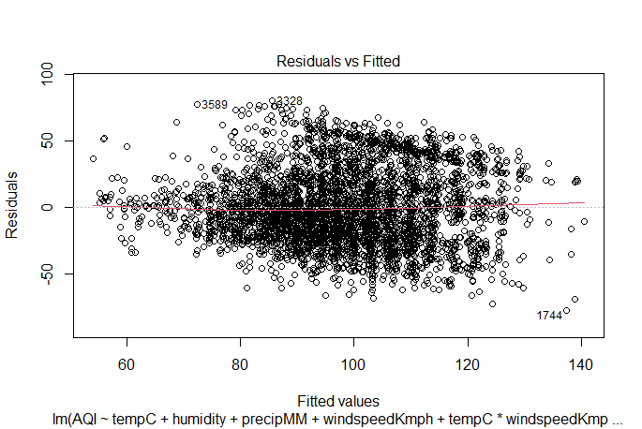

For Models 7 and 8, two continuous independent variables were multiplied with each other to find out the interactive impact of the independent pair on the dependent variable, AQI. Model 7 examines the interactive impact of pairs: Temperature & Wind speed, Temperature & Humidity, and Temperature & Precipitation on the dependent variable. Model 7 has an R-square of 19.5%, which means this model can explain 19.5% of the variability of AQI. The adjusted R-squared has increased slightly from 19% in Model 6, to 20% in Model 7. All of the variables are statistically significant with a confidence interval of approximately 99%.

Wind speed has a coefficient of -1.15, which means that if wind speed increases by 1 km/h, AQI levels will decrease by 1.15, temperature with wind speed has a coefficient of 2.863 which means, the higher the temperature, the more negative impact of wind speed on AQI. Precipitation with wind speed has a coefficient of 3.17, indicating that the more precipitation, the more negative the impact of wind speed on AQI. And finally, temperature with humidity has a coefficient of -3.18, which means that when temperature increases, the impact of humidity on AQI levels is negative. In other words, the higher the temperature, the more negative the impact of humidity on AQI

The residual plot shows that the residuals are not very equally distributed across the regression line above and below the regression line. There is no pattern between residuals and fitted AQI, therefore there is no non- linear relationship between AQI and dependent variables.

**Chi-square tests**

Chi-square tests were performed as an additional method to determine the relationship between weather and AQI levels, with H0 indicating that there is NO relationship between the variables and H1 indicating that there is a relationship between the variables:

|  |  |  |  |  |
| --- | --- | --- | --- | --- |
| **Variables** | **df** | **X-squared** | **p-value** | **Comments** |
| AQI & weather | 45 | 211.67 | < 2.2e-16 | Reject H0, accept H1 |
| AQI & humidity | 12 | 115.26 | < 2.2e-16 | Reject H0, accept H1 |
| AQI & temperature | 6 | 83.572 | 6.522e-16 | Reject H0, accept H1 |
| AQI & precipitation | 6 | 2.427 | 0.8765 | Can’t reject H0 |
| AQI & wind speed | 12 | 164.99 | < 2.2e-16 | Reject H0, accept H1 |

From the chi-square test, we can conclude that the below pairs show a relationship between each other: AQI & weather; AQI & humidity; AQI & temperature; and AQI & wind speed.

**Conclusion**

The linear model performed with the dataset using a 3-day time lag (Model 5) and a 7-day time lag (Model 6) achieved better R-square results, with Model 5 explaining 12% of the variability of AQI levels and Model 6 explaining 18% of the variability. Using the CramerV method and correlation r for numeric variables, some of the results were contradictory:

* AQI & Wind speed and AQI & humidity are two pairs that have opposite correlations with both methods;
* Using the CramerV method, AQI increases while Wind speed decreases; using the correlation method, both AQI and Wind speed increase relative to each other;
* The two pairs, AQI & Weather and AQI & Temperature, have the same results using both methods (each variable moves in the same direction)

Using chi-square tests, we can conclude that there is a relationship between AQI and the following variables: weather, humidity, temperature, and wind speed.

**Recommendations**

Air pollution levels can have a significant impact on the health of people living in Ho Chi Minh City. Providing advance notice to people about worsening air quality would enable them to modify their behavior during those times, such as avoiding strenuous activities. It also enables the government to put in temporary measures to reduce activities that generate pollution, such as demolitions of old buildings or reducing traffic congestion. While it is generally difficult to directly predict air pollution levels for a given day, it is much easier to predict weather patterns, including precipitation, wind speed, humidity, and temperature. By using weather forecasts, governments can provide advisories to people, especially those more susceptible to the health impacts of air pollution, to avoid strenuous activities on those days, such as avoiding exercise, cycling, or walking long distances. Government can also take temporary measures to suspend construction-related work, requiring work places stagger start and end times, or prohibiting certain types of traffic at specific times of the day.

**Conclusions**

Industrialization and increasing wealth have gone hand in hand with pollution in every country over the last three centuries. Unsurprisingly, air pollution levels in Ho Chi Minh City have significantly increased over the decades since the rapid industrialization of Vietnam. Over the last 5 years, it appears that these have been decoupled, with economic growth continuing but a plateauing and even a reversal in the growth in air pollution levels. This is observed by looking at air pollution levels in the month of December in each of the last 5 years, from a high in 2016 to a low in 2020. There is also less variability in air pollution levels, with fewer time periods of extreme and high levels. This is likely due to concerted action on the part of local authorities to reduce reliance on private vehicles, encouraging people to use public transport, and reducing congestion by varying working and school hours. Work is currently underway to invest in better public transport systems, including bus rapid transit in Ho Chi Minh City. However, with air pollution levels that are unhealthy or unhealthy for sensitive groups around one-fifth of the time, levels are still quite high and will continue to affect people’s health.

When looking at two different times of year, February 2021 and December 2020, February did experience higher levels of air pollution but the difference was quite small. However, with the COVID-19 pandemic restricting many of the pollution-causing activities that usually take place in February around the Tet festival, pollution levels in February 2021 may have been significantly lower than usual.

Weather can explain some of the variability in air pollution levels. Some methods to explain the variability in air pollution levels were not successful, providing contradictory results. Using the CramerV method, it was found that AQI levels increase when wind speed decreases, whereas the correlation method found that AQI levels increase when wind speed increases. However, AQI levels were found to increase as temperature increased using both the CramerV and correlation methods.

Chi-square tests showed that there is a relationship between AQI levels and four weather-related variables: weather, humidity, temperature, and wind speed. Various linear regression models were tested in order to find the best predictors for air quality. Model 5 and 6, which combine Temperature, Humidity, Wind speed and Precipitation as predictors for air quality, and which uses a 3-day time lag and 7-day time lag, respectively with air quality being measured 7 days later, achieved the adjusted R-squared increased from 11% for Model 5 to 18% for Model 6. The model that has the highest R-square, 20%, is model 8, which we multiplied each two independent variables with each other to see the interactive impact of each pair on AQI and the dataset being used is 7-day time lag.

The model with the time lag datasets explains the expert’s sentiments or scientific evidence, presented in the background. Science is evidence-based that can’t be observed with naked eye. For example, today it may be a normal sunny day with average speeds of wind, but a few days ago, the city could have been covered with cold air like a blanket, accumulating fine dust that cannot spread causing the pollution index to rise. It is a combination of many factors: temperature, wind, dust dispersion. This does not mean that more vehicles will cause pollution to increase.

This model can be used to predict air quality 7 days into the future, providing a useful tool for the government to take action in advance to reduce the health impacts of air pollution.

**Appendix A: Description of Dataset Variables**

|  |  |  |  |
| --- | --- | --- | --- |
| **Name of Variable** | **Description of Variable** | **Type of Variable** | **Source** |
| Site | Subject location of the observations. All observations are from Ho Chi Minh City, Vietnam. | Categorical variable | U.S. Consulate General Ho Chi Minh City |
| Parameter | describes what is being measured by the data. Data is for pollution particles that are 2.5 microns in diameter or smaller. | Categorical variable | U.S. Consulate General Ho Chi Minh City |
| Date_LT | Provides the date and time the air pollution information was collected at, taken at 1 hour intervals. | Numerical variable | U.S. Consulate General Ho Chi Minh City |
| Year | The year in which the information was collected, all information was collected in 2019. | Numerical variable | U.S. Consulate General Ho Chi Minh City |
| Month | Month in which the information was collected. | Numerical variable | U.S. Consulate General Ho Chi Minh City |
| Day | Day of which the information was collected | Numerical variable | U.S. Consulate General Ho Chi Minh City |
| Hour | The time of day at which the information was collected. | Numerical variable | U.S. Consulate General Ho Chi Minh City |
| AQI | The AQI (air quality index) level is calculated based on the NowCast Conc. data. | Numerical variable | U.S. Consulate General Ho Chi Minh City |
| AQI_Category | The AQI level is converted into one of 6 AQI Categories: Good, Moderate, Unhealthy for Sensitive Groups, Unhealthy, Very Unhealthy, and Hazardous. | Categorical variable | U.S. Consulate General Ho Chi Minh City |
| Raw_Conc | Raw concentration is the air pollution levels of particulates 2.5 microns in diameter or smaller and a specific point in time, measured in UG/M3. | Numerical variable | U.S. Consulate General Ho Chi Minh City |
| Conc_Unit | Unit of measurement to describe the data in the previous column. | Categorical variable | U.S. Consulate General Ho Chi Minh City |
| Duration | Duration states how long the PM2.5 was measured for and is the standard duration for collecting air pollution data | Numerical variable | U.S. Consulate General Ho Chi Minh City |
| QC_Name | Quality control status of the observation. There are three variables: Valid, Invalid, and Missing. | Categorical variable | U.S. Consulate General Ho Chi Minh City |
| Weather | Weather condition description | Categorical variable | Historical Forecast Weather: [Historical Weather Forecasts | World Weather Online](https://www.worldweatheronline.com/hwd/hfw.aspx) |
| Precipitation_mm | Total precipitation amount in mm | Numerical variable | Historical Forecast Weather: [Historical Weather Forecasts | World Weather Online](https://www.worldweatheronline.com/hwd/hfw.aspx) |
| TempC | Temperature in degrees Celsius. | Numerical variable | Historical Forecast Weather: [Historical Weather Forecasts | World Weather Online](https://www.worldweatheronline.com/hwd/hfw.aspx) |
| WindspeedKmph | Wind speed in kilometers per hour | Numerical variable | Historical Forecast Weather: [Historical Weather Forecasts | World Weather Online](https://www.worldweatheronline.com/hwd/hfw.aspx) |
| Humidity | Humidity in percentage (%) | Numerical variable | Historical Forecast Weather: [Historical Weather Forecasts | World Weather Online](https://www.worldweatheronline.com/hwd/hfw.aspx) |

**Appendix B: SAS codes for combining and cleaning dataset**

Data HCMC2016_12;

infile '/folders/myfolders/Team project/AQI_december/HoChiMinhCity_PM2.5_2016_12_MTD.csv' dlm=',' firstobs=2 missover dsd;

      format Site $5.

             Parameter $17.

             Date_LT_ DATETIME13.

             Year 4.

             Month 2.

             Day 2.

             Hour 2.

             AQI 4.

             AQI_Category $30.

             _24_hr_MidPt_Avg 4.1

             Raw_Conc 3.

             Conc_Unit $5.

             Duration $4.

             QC_Name $10.

             Weather_Description $29.

             Precipitation_mm 3.1

             Precipitation_inches 3.1

             Temp_C         2.

             Wind_speed_Kmph 2.

             Humidity 2.

             Heat_Index_C 2.  ;

      input Site $ Parameter $ Date_LT_:ANYDTDTM40. Year Month Day Hour AQI AQI_Category $ _24_hr_MidPt_Avg Raw_Conc Conc_Unit $ Duration $ QC_Name $ Weather_Description $ Precipitation_mm Precipitation_inches Temp_C  Wind_speed_Kmph Humidity Heat_Index_C ;

      options datestyle=dmy;

*cleaning dataset ;

*Changing AQI category according to the value of AQI;

if AQI_Category = 2 then AQI_Category='Moderate';

else if AQI_Category = 3 then AQI_Category='Unhealthy for Sensitive Groups';

else if AQI_Category = 4 then AQI_Category='Unhealthy';

*Removing outliers ;

if Raw_Conc=985 then delete;

*dropping 24 hr mid pt. avg column for merging purpose;

drop _24_hr_MidPt_Avg;

run;

**************************************************************************;

Data HCMC2017_12;

infile '/folders/myfolders/Team project/AQI_december/HoChiMinhCity_PM2.5_2017_12_MTD.csv' dlm=',' firstobs=2 missover dsd;

     format Site $5.

             Parameter $17.

             Date_LT_ DATETIME13.

             Year 4.

             Month 2.

             Day 2.

             Hour 2.

             NowCast_Conc 5.1

             AQI 4.

             AQI_Category $30.

             Raw_Conc 5.1

             Conc_Unit $5.

             Duration $4.

             QC_Name $10.

             Weather_Description $29.

             Precipitation_mm 3.1

             Precipitation_inches 3.1

             Temp_C         2.

             Wind_speed_Kmph 2.

             Humidity 2.

             Heat_Index_C 2. ;

      input Site $ Parameter $ Date_LT_:ANYDTDTM40. Year Month Day Hour NowCast_Conc AQI AQI_Category $ Raw_Conc Conc_Unit $ Duration $ QC_Name $ Weather_Description $ Precipitation_mm Precipitation_inches Temp_C Wind_speed_Kmph Humidity Heat_Index_C ;

      options datestyle=dmy;

*Removing missing values;

if Raw_Conc=-999 or Raw_Conc=985 then delete;

if NowCast_Conc=-999 then delete;

if AQI=-999 then delete;

*dropping NowCast_Conc column for merging purpose;

drop NowCast_Conc;

run;

*********************************************************************;

Data HCMC2018_12;

infile '/folders/myfolders/Team project/AQI_december/HoChiMinhCity_PM2.5_2018_12_MTD.csv' dlm=',' firstobs=2 missover dsd;

      format Site $5.

             Parameter $17.

             Date_LT_ DATETIME13.

             Year 4.

             Month 2.

             Day 2.

             Hour 2.

             NowCast_Conc 5.1

             AQI 4.

             AQI_Category $30.

             Raw_Conc 5.1

             Conc_Unit $5.

             Duration $4.

             QC_Name $10.

             Weather_Description $29.

             Precipitation_mm 3.1

             Precipitation_inches 3.1

             Temp_C         2.

             Wind_speed_Kmph 2.

             Humidity 2.

             Heat_Index_C 2. ;

      input Site $ Parameter $ Date_LT_:ANYDTDTM40. Year Month Day Hour NowCast_Conc AQI AQI_Category $ Raw_Conc Conc_Unit $ Duration $ QC_Name $ Weather_Description $ Precipitation_mm Precipitation_inches Temp_C Wind_speed_Kmph Humidity Heat_Index_C  ;

      options datestyle=dmy;

  *data cleaning;

*removing missing data;

if NowCast_Conc= -999 then delete;

if AQI= -999 then delete;

*there are missing data of -999, outliers 985 and 0 as values for raw conc. removing them;

if Raw_Conc <1 or Raw_Conc=985 then delete;

 *dropping NowCast_Conc column for merging purpose;

drop NowCast_Conc;

run;

***********************************************************************;

Data HCMC2019_12;

infile '/folders/myfolders/Team project/AQI_december/HoChiMinhCity_PM2.5_2019_12_MTD.csv' dlm=',' firstobs=2 missover dsd;

      format Site $5.

             Parameter $17.

             Date_LT_ DATETIME13.

             Year 4.

             Month 2.

             Day 2.

             Hour 2.

             NowCast_Conc 5.1

             AQI 4.

             AQI_Category $30.

             Raw_Conc 5.1

             Conc_Unit $5.

             Duration $4.

             QC_Name $10.

             Weather_Description $29.

             Precipitation_mm 3.1

             Precipitation_inches 3.1

             Temp_C         2.

             Wind_speed_Kmph 2.

             Humidity 2.

             Heat_Index_C 2. ;

      input Site $ Parameter $ Date_LT_:ANYDTDTM40. Year Month Day Hour NowCast_Conc AQI AQI_Category $ Raw_Conc Conc_Unit $ Duration $ QC_Name $ Weather_Description $ Precipitation_mm Precipitation_inches Temp_C Wind_speed_Kmph Humidity Heat_Index_C  ;

      options datestyle=dmy;

*data cleaning;

*removing missing data;

if NowCast_Conc= -999 then delete;

if AQI= -999 then delete;

*removing outliers;

if Raw_Conc=985 then delete;

 *dropping NowCast_Conc column for merging purpose;

drop NowCast_Conc;

run;

***********************************************************************;

Data HCMC2020_12;

infile '/folders/myfolders/Team project/AQI_december/HoChiMinhCity_PM2.5_2020_12_MTD.csv' dlm=',' firstobs=2 missover dsd;

     format Site $5.

             Parameter $17.

             Date_LT_ DATETIME13.

             Year 4.

             Month 2.

             Day 2.

             Hour 2.

             NowCast_Conc 5.1

             AQI 4.

             AQI_Category $30.

             Raw_Conc 5.1

             Conc_Unit $5.

             Duration $4.

             QC_Name $10.

             Weather_Description $29.

             Precipitation_mm 3.1

             Precipitation_inches 3.1

             Temp_C         2.

             Wind_speed_Kmph 2.

             Humidity 2.

             Heat_Index_C 2.;

     input Site $ Parameter $ Date_LT_:ANYDTDTM40. Year Month Day Hour NowCast_Conc AQI AQI_Category $ Raw_Conc Conc_Unit $ Duration $ QC_Name $ Weather_Description $ Precipitation_mm Precipitation_inches Temp_C Wind_speed_Kmph Humidity Heat_Index_C ;

      options datestyle=dmy;

*data cleaning;

*removing missing data ;

if NowCast_Conc= -999 then delete;

if AQI= -999 then delete;

*there are missing data of -999 and outliers 985 as values for raw conc. - Removing them;

if Raw_Conc <1 or Raw_Conc=985 then delete;

*dropping NowCast_Conc column for merging purpose;

drop NowCast_Conc;    
run;

***********************************************************************;

Data HCMC2021_02;

infile '/folders/myfolders/Team project/AQI_december/HoChiMinhCity_PM2.5_2021_02_MTD.csv' dlm=',' firstobs=2 missover dsd;

      format Site $5.

             Parameter $17.

             Date_LT_ DATETIME13.

             Year 4.

             Month 2.

             Day 2.

             Hour 2.

             NowCast_Conc 5.1

             AQI 4.

             AQI_Category $30.

             Raw_Conc 5.1

             Conc_Unit $5.

             Duration $4.

             QC_Name $10.

             Weather_Description $29.

             Precipitation_mm 3.1

             Precipitation_inches 3.1

             Temp_C         2.

             Wind_speed_Kmph 2.

             Humidity 2.

             Heat_Index_C 2.;

      input Site $ Parameter $ Date_LT_:ANYDTDTM40. Year Month Day Hour NowCast_Conc AQI AQI_Category $ Raw_Conc Conc_Unit $ Duration $ QC_Name $ Weather_Description $  Precipitation_mm Precipitation_inches Temp_C Wind_speed_Kmph Humidity Heat_Index_C ;

      options datestyle=dmy;

*dropping NowCast_Conc column for merging purpose;

drop NowCast_Conc;

run;

*********************************************************************;

**\*\*\*\*\*\*\*\*\*\*\*\*\*\*\*\*\*\*\*\*\*\*\*\*\*\*\*\*\*\*\*\*\*Merging****************************;**

Data HCMC_master;

*Merging all the datasets;

set  HCMC2016_12  HCMC2017_12  HCMC2018_12  HCMC2019_12  HCMC2020_12 HCMC2021_02 ;

run;

**\*\*Lockdown Analysis**;**

**********************************************************************;

Data HCMC2020_12_lockdown;

infile '/folders/myfolders/Team project/lockdown analysis/HoChiMinhCity_PM2.5_2020_12_lockdown.csv' dlm=',' firstobs=2 missover dsd;

      format

             Site $5.

             Parameter $17.

             Date_LT_ DATETIME13.

             Year 4.

             Month 2.

             Day 2.

             Hour 2.

             NowCast_Conc 5.1

             AQI 4.

             AQI_Category $30.

             Raw_Conc 5.1

             Conc_Unit $5.

             Duration $4.

             QC_Name $10.;

      input Site $ Parameter $ Date_LT_:ANYDTDTM40. Year Month Day Hour NowCast_Conc AQI AQI_Category $ Raw_Conc Conc_Unit $ Duration $ QC_Name $ ;

      options datestyle=dmy;

*data cleaning;

*deleting  missing data;

if NowCast_Conc= -999 then delete;

if AQI= -999 then delete;

*there are missing data of -999 and outliers 985 as values for raw conc. - deleting them;

if Raw_Conc <1 or Raw_Conc=985 then delete;

*Changing AQI category according to AQI value;

If AQI >=51 and AQI <=100 then AQI_Category ='Moderate';

run;

***********************************************************************;

Data HCMC2021_02_lockdown;

infile '/folders/myfolders/Team project/lockdown analysis/HoChiMinhCity_PM2.5_2021_02_lockdown.csv' dlm=',' firstobs=2 missover dsd;

      format Site $5.

             Parameter $17.

             Date_LT_ DATETIME13.

             Year 4.

             Month 2.

             Day 2.

             Hour 2.

             NowCast_Conc 5.1

             AQI 4.

             AQI_Category $30.

             Raw_Conc 5.1

             Conc_Unit $5.

             Duration $4.

             QC_Name $10.;

      input Site $ Parameter $ Date_LT_:ANYDTDTM40. Year Month Day Hour NowCast_Conc AQI AQI_Category $ Raw_Conc Conc_Unit $ Duration $ QC_Name $ ;

      options datestyle=dmy;

*data Cleaning;

*deleting outliers;

if Raw_Conc <1 or Raw_Conc=985 then delete;

run;

**\*\*\*\*\*\*\*\*\*\*\*\*\*\*\*\*\*\*\*\*\*\*\*\*\*\*\*\*Merging******************************;**

***merging 2 datasets for post and pre lockdown analysis***;

data lockdown_analysis;

set HCMC2020_12_lockdown HCMC2021_02_lockdown ;

run;

**Appendix C: NowCast, AQI levels, and AQI categories**

NowCast using the following formula to take the Raw Concentration data from the previous 12 hours, weighting recent observations more heavily:

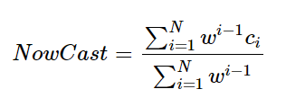

C1, C2…. C12 are the Raw Concentration levels and Wi is the weighting.

The following chart shows how the NowCast data is converted into the AQI levels and the AQI categories:

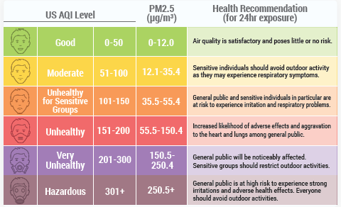

**Appendix D: SAS codes for changes in air quality 2016-2017**

**AQI Category Frequencies**

proc sort data=PROJECT.QUERY out=Work.SortTempTableSorted;

       by Year;

run;

proc freq data=Work.SortTempTableSorted;

       tables AQI_Category / nocum plots=(freqplot);

       by Year;

run;

proc delete data=Work.SortTempTableSorted;

run;

**AQI and Raw Concentration box plots**

ods graphics / reset width=6.4in height=4.8in imagemap;

proc sgplot data=PROJECT.QUERY;

       title height=14pt "AQI by Year";

       vbox AQI / category=Year;

       yaxis grid;

run;

ods graphics / reset;

title;

graphics / reset width=6.4in height=4.8in imagemap;

proc sgplot data=PROJECT.QUERY;

       title height=14pt "Raw Concentration by Year";

       vbox Raw_Conc / category=Year;

       yaxis grid;

run;

ods graphics / reset;

title;

**AQI and Raw Concentration summary statistics**

ods noproctitle;

ods graphics / imagemap=on;

proc sort data=PROJECT.QUERY out=WORK.TempSorted2236;

       by Year;

run;

proc means data=WORK.TempSorted2236 chartype mean std min max median stderr var

             mode range vardef=df cv q1 q3 qrange qmethod=os;

       var AQI Raw_Conc;

       by Year;

run;

proc univariate data=WORK.TempSorted2236 vardef=df noprint;  
       var AQI Raw_Conc;

       histogram AQI Raw_Conc;

       by Year;

run;

proc datasets library=WORK noprint;

       delete TempSorted2236;

       run;

**Appendix E: Distribution of AQI and Raw Concentration Levels**

The graphs below show the frequency of AQI levels:

|  |  |
| --- | --- |
|  |  |
|  |  |
|  | |

The graphs below show the frequency of Raw Concentration levels:

|  |  |
| --- | --- |
|  |  |
|  |  |
|  | |

**Appendix F: SAS Codes for Changes in Air Quality (February 2021 vs December 2020)**

/**Deleting Data for month 1**/

proc sql;

delete from DECVSFEB_ANALYSIS

where month = 1;

run;

/**Descriptive statistics of AQI**/

ods noproctitle;

proc sort data=WORK.DECVSFEB_ANALYSIS out=_chardata_sorted;

by Month;

run;

title "Descriptive Statistics for Numeric Variables";

proc means data=_chardata_sorted n nmiss min mean median max std;

by Month;

var AQI;

run;

title;

proc univariate data=_chardata_sorted noprint;

by Month;

histogram AQI;

run;

proc delete data=_chardata_sorted;

run;

/**BoxPlot AQI by month**/

ods graphics / reset width=6.4in height=4.8in imagemap;

proc sgplot data=WORK.DECVSFEB_ANALYSIS;

vbox AQI / category=Month;

yaxis grid;

run;

ods graphics / reset;

/**Descriptive statistics of AQI_Category**/

proc sort data=DECVSFEB_ANALYSIS out=Work.SortTempTableSorted;

by Month;

run;

proc freq data=Work.SortTempTableSorted;

tables AQI_Category / nocum plots=(freqplot);

by Month;

run;

proc delete data=Work.SortTempTableSorted;

run;

/**side-by-side bar chart of AQI_Category feb vs dec**/

ods graphics / reset width=6.4in height=4.8in imagemap;

proc sgplot data=WORK.DECVSFEB_ANALYSIS;

vbar AQI_Category / group=Month groupdisplay=cluster stat=percent datalabel;

yaxis grid;

run;

ods graphics / reset;

/**Descriptive statistics of Raw_Conc**/

ods noproctitle;

proc sort data=WORK.DECVSFEB_ANALYSIS out=_chardata_sorted;

by Month;

run;

title "Descriptive Statistics for Numeric Variables";

proc means data=_chardata_sorted n nmiss min mean median max std;

by Month;

var Raw_Conc;

run;

title;

proc univariate data=_chardata_sorted noprint;

by Month;

histogram Raw_Conc;

run;

proc delete data=_chardata_sorted;

run;

/**BoxPlot Raw_Conc by month**/

ods graphics / reset width=6.4in height=4.8in imagemap;

proc sgplot data=WORK.DECVSFEB_ANALYSIS;

vbox Raw_Conc / category=Month;

yaxis grid;

run;

ods graphics / reset;

**Appendix G: R- Codes for Relationship between Weather and Air Quality**

setwd('C:/Users/LIEN PHAM/Desktop/Langara/Data analysis and statistics infer/Project/Team Project attached files')

getwd

library("readxl")

library(tidyverse)

library(lubridate)

link = dir("C:/Users/LIEN PHAM/Desktop/Langara/Data analysis and statistics infer/Project/Team Project attached files",

full.names = FALSE)

str(link)

link = link[str_detect(link, "csv")]

df_17_21 <- data.frame()

for (i in (1:length(link))){

# Import file

df <- read.csv(file = paste0("C:/Users/LIEN PHAM/Desktop/Langara/Data analysis and statistics infer/Project/Team Project attached files/",

link[i]))

# Merge file

df_17_21%>%

rbind(df) -> df_17_21

}

df_17_21= df_17_21 %>%

select(- NowCast.Conc.)

# $ Date..LT. : chr "12/1/2017 1:00" "12/1/2017 2:00" "12/1/2017 3:00" "12/1/2017 4:00" ...

df_2016 <- read.csv("C:/Users/LIEN PHAM/Desktop/Langara/Data analysis and statistics infer/Project/HoChiMinhCity_PM2.5_2016_12_MTD.csv")

df_2016 = df_2016 %>%

select(- X24.hr..Midpoint.Avg..Conc.)

# Merge all the raw files (2016 - 2021) for checking missing data purpose

df_master = rbind(df_2016,df_17_21)

View(df_master)

#4224 obs. of 13 variables

# checking NA/missing values for all variables (NO missing values for all variables)

df_master %>%

select(everything()) %>%

summarise_all(funs(sum(is.na(.)))) -> missing_values

# checking outliners (147 obs with outliners)

df_master %>%

filter(!AQI>=0 |!AQI<=176) -> df_master_check_outliners

View(df_master_check_outliners)

df_master %>%

filter(!Raw.Conc. >0 |! Raw.Conc. < 985) -> df_master_check_outliners_Rawconc

View(df_master_check_outliners_Rawconc) # 28 obs removed

df_master = df_master %>%

filter( AQI>=0 & AQI<=176,Raw.Conc. >0 & Raw.Conc. < 985 )

View(df_master) #(4049 obs including all years: 2016,2017,2018,2019,2020,2021)

external_data <- read.csv("C:/Users/LIEN PHAM/Desktop/Langara/Data analysis and statistics infer/Project/weather_data_1hr.csv")

external_data = external_data %>%

select(date,time,weatherDesc,precipMM,precipInches,tempC,windspeedKmph,humidity,HeatIndexC)

external_data = external_data %>%

mutate(Time = time/100)

external_data = external_data %>%

select(-time)

# change format of Date for external data

external_data$date_new = as.Date(external_data$date,format = c("%m/%d/%Y"))

# change format of Date for master data for merging

as.Date ("2018-12-01 01:00 AM", format = "%Y-%m-%d")

# "2018-12-01"

as.Date ("12/1/2017 1:00", format = "%m-%d-%Y")

df_master$date_new = as.Date(df_master$Date..LT.,format = c("%m/%d/%Y"))

df_master[is.na(df_master$date_new), "date_new"] = as.Date(df_master[is.na(df_master$date_new), "Date..LT."], format = "%Y-%m-%d")

df_master[is.na(df_master$date_new), c("date_new", "Date..LT.")]

# combine master file with external dataset

library(lubridate)

joined_df <- left_join(df_master,external_data, by = c("date_new" = "date_new", "Hour" = "Time"))

View(joined_df)

joined_df[2977, c("date_new", "Hour", "Date..LT.")]

df_master[is.na(df_master$date_new),]

join_df_16_20 = joined_df %>%

filter(date_new >= "2016-12-01" & date_new <= "2020-12-31")

max(joined_df$date_new, na.rm = T) # check

unique(joined_df$date_new)

join_df_16_20 = joined_df %>%

filter(date_new >= "2016-12-01" & date_new <= "2020-12-31")

unique(joined_df$AQI.Category)

# fix the AQI categories for the consistency

joined_df = joined_df %>%

filter(AQI > 0) %>%

mutate(AQI_bin = case_when(AQI.Category == "2" ~ "Moderate",

AQI.Category == "3" ~ "Unhealthy for Sensitive Groups",

AQI.Category == "4" ~ "Unhealthy",

TRUE ~ AQI.Category))

joined_df$AQI_bin = as.factor(joined_df$AQI_bin)

unique(joined_df_fix$weatherDesc)

joined_df %>% group_by(weatherDesc) %>% count()

write_xlsx(joined_df,'C:/Users/LIEN PHAM/Desktop/Langara/Data analysis and statistics infer/Project/joined_df.xlsx')

##############################################################################

df_daily_all_variables = joined_df %>%

group_by(date_new) %>%

summarise(daily_AQI = sum(AQI),

daily_wind = sum(windspeedKmph),

daily_tempC = sum(tempC),

daily_preci = sum(precipMM),

daily_hum = sum(humidity))

library("writexl")

write_xlsx(df_daily_all_variables,'C:/Users/LIEN PHAM/Desktop/Langara/Data analysis and statistics infer/Project/df_daily_all_variables.xlsx')

df_daily_AQI = joined_df %>%

group_by(date_new) %>%

summarise(daily_AQI = sum(AQI))

df_daily_AQI$date_new = as.Date(df_daily_AQI$date_new)

# plot daily AQI to find the dates with max AQI (3823 for 10/12/2016)

library(dplyr)

ggplot(data = df_daily_AQI) +

geom_line(aes(date_new,daily_AQI))+

geom_point(aes(date_new,daily_AQI)) +

geom_text(data = df_daily_AQI %>% dplyr::filter(daily_AQI == max(df_daily_AQI$daily_AQI)),

aes(date_new,daily_AQI, label = date_new), vjust = -0.3)

# Using yearly data, generate: a boxplot and a bar plot (choose one of variables)

joined_df$Year = as.factor(joined_df$Year)

joined_df %>% ggplot() + geom_boxplot(aes(x = Year, y = AQI, fill = Year))

joined_df %>% ggplot() + geom_col(aes(x = Year, y = AQI, fill = Year))

# The distributions of AQI, EACH month of HCMC

joined_df %>% ggplot() + geom_histogram(aes(AQI), fill = "lightblue", binwidth = 15) +

facet_wrap(~ Year)

############################################

# caterogize the wind_speed

library(lsr)

install.packages("DescTools")

library(DescTools)

joined_df %>%

arrange(Wind_speed_Kmph) %>%

View()

hist(joined_df$windspeedKmph)

quantile_windspeed <- quantile(joined_df$windspeedKmph,probs = seq(0, 1, 1/5))

group_windspeed <- cut(joined_df$windspeedKmph,c(0,5,6,8,10,24), labels = c("very_low","low","medium","high","very_high"),

right = FALSE, include.lowest = TRUE)

table(group_windspeed, joined_df$AQI_bin)

tab <- table(group_windspeed, joined_df$AQI_bin)

CramerV(tab, bias.correct = FALSE) # r = 0.1165437 (Windspeed & AQI)

Phi(tab)

ContCoef(tab)

TschuprowT(tab)

tab4 <- table(joined_df$weatherDesc, joined_df$AQI_bin)

CramerV(tab4, bias.correct = FALSE) # r = 0.1334249 (weather & AQI)

# caterogize the precipMM

joined_df %>%

arrange(precipMM) %>%

View()

hist(joined_df$precipMM)

quantile_preciMM <- quantile(joined_df$precipMM, probs = seq(0, 1, 1/5))

group_preciMM <- cut(joined_df$windspeedKmph,c(0,0.5,2,5.6), labels = c("low","medium","high"),

right = FALSE, include.lowest = TRUE)

tab1 <- table(group_preciMM,joined_df$AQI_bin)

CramerV(tab1, bias.correct = FALSE) # 0.03355126 (AQI & preciMM)

# caterogize the tempC

joined_df %>%

arrange(tempC) %>%

View()

hist(joined_df$tempC)

quantile_tempC <- quantile(joined_df$tempC,probs = seq(0, 1, 1/3))

group_tempC <- cut(joined_df$tempC,c( 20,25,28,36),labels = c("low","medium","high"),

right = FALSE, include.lowest = TRUE)

tab2<- table(group_tempC,joined_df$AQI_bin)

CramerV(tab2, bias.correct = FALSE) # 0.1015877 (AQI & tempC)

joined_df %>% group_by(tempC) %>% count()

# caterogize the humidity

joined_df %>%

arrange(humidity) %>%

View()

hist(joined_df$humidity)

quantile_humidity <- quantile(joined_df$humidity,probs = seq(0, 1, 1/5))

group_humidity <- cut(joined_df$humidity,c(29,59,68,75,83,98), labels = c("very_low","low","medium","high","very_high"),

right = FALSE, include.lowest = TRUE)

tab3 <- table(group_humidity,joined_df$AQI_bin)

CramerV(tab3, bias.correct = FALSE) # 0.09740825 (AQI & humidity)

############################################

#correlation relationship (for numeric variables)

summary <- summary(joined_df[,c(8,10, 17:22)])

joined_df_re_col<- joined_df[,-c(1:7,9:16,23)] # remove columns (chr)

all_correlation <-cor(joined_df_re_col, use = "complete.obs")

install.packages("Hmisc")

library("Hmisc")

plot(AQI ~ tempC + windspeedKmph + tempC*windspeedKmph, data = joined_df_re_col, main = "Plot")

pairs(~tempC + windspeedKmph + tempC*windspeedKmph,data = joined_df_re_col,

main="Simple Scatterplot Matrix")

############################################

# Linear model

lag_data <- read_excel("df_daily_all_variables.xlsx",sheet = "Sheet2")

LM_lag_data <- lm (AQI ~ tempC + humidity + precipMM + windspeedKmph, data = joined_df )

summary(LM)

LM_mul <- lm(AQI ~ tempC + windspeedKmph + tempC*windspeedKmph, data = joined_df)

summary(LM_mul)

###########################################

LM <- lm (AQI ~ tempC + humidity + precipMM + windspeedKmph, data = joined_df)

summary(LM)

lm_1<- lm (AQI ~ tempC , data = joined_df)

summary(lm_1)

abline(lm_1)

lm_2<- lm (AQI ~ humidity , data = joined_df)

summary(lm_2)

abline(lm_2)

lm_3<- lm (AQI ~ precipMM , data = joined_df)

summary(lm_3)

abline(lm_3)

lm_4<- lm (AQI ~ windspeedKmph, data = joined_df)

summary(lm_4)

abline(lm_4)

###############################################################

# Perform LM with lag-time dataset

setwd('C:/Users/LIEN PHAM/Desktop/Langara/Data analysis and statistics infer/Project')

getwd

library("readxl")

df_3 = read_excel("joined_df _lag_3.xlsx")

df_7 = read_excel("joined_df _lag_7.xlsx")

lm_6 <- lm(AQI ~ tempC + humidity + precipMM + windspeedKmph, data = df_3)

summary(lm_6)

LM_mul_lag7 <- lm(AQI ~ tempC + windspeedKmph + tempC*windspeedKmph, data = df_7)

summary(LM_mul_lag7)

LM_mul_lag7_tempC <- lm(AQI ~ tempC + humidity + precipMM + windspeedKmph + tempC*windspeedKmph + tempC*humidity + tempC*precipMM, data = df)

summary(LM_mul_lag7_tempC)

LM_mul_lag7_all <- lm(AQI ~ tempC + humidity + precipMM + windspeedKmph + tempC*windspeedKmph

+ tempC*humidity + tempC*precipMM + humidity*precipMM + humidity*windspeedKmph

+ precipMM*windspeedKmph, data = df_7)

MD8 <- summary(LM_mul_lag7_all)

plot(LM_mul_lag7_all, which = 1)

#############################################################

# find dates

date_day <- weekdays(as.Date(joined_df$date_new))

joined_df$date_day = date_day

View(joined_df)

# total 1195 weekend days and 573 days with Unhealthy or Unhealthy for sensitive groups (accounts for 49%)

weekend = joined_df %>%

filter(date_day%in% c('Saturday','Sunday') &

AQI_bin %in% c('Unhealthy for Sensitive Groups','Unhealthy'))

as.factor(weekend$date_day)

weekend %>% ggplot() + geom_bar(mapping = aes(x = AQI))

###############################################################

# Perform chi-square test

chisq.test(joined_df$AQI_bin,joined_df$weatherDesc)

chisq.test(joined_df$AQI_bin,group_humidity)

chisq.test(joined_df$AQI_bin,group_tempC)

chisq.test(joined_df$AQI_bin,group_preciMM)

chisq.test(joined_df$AQI_bin,group_windspeed)

**Appendix H: Distribution of variables and example of binning techniques**

|  |  |
| --- | --- |
| https://lh4.googleusercontent.com/cGB-_KSIjr2CHJ7D8Xg8KEOtp5Zgus6KP_choE2cHCHx4Xh51cmDP3QKGyRywfgHOzLcVRlIm7LHreY6x0T7Flw3xSDVdPzS_p_XfPgZg0DkQT0IcfmusFP53mZNI6bcSyPZhv4 | https://lh3.googleusercontent.com/L7sm7iGa6h9Ve1hMIdWa5vnT3mBzl6pFkH2NzvbiBirk7fsMwVA2oz70TTf1IsfZXTt9__930g-4FvzII7iaeQDh73NwgCrJb8vEUhRZ5k_9gXC5mVcRnQc5x5dr_mQVZZxBQgk |
| https://lh3.googleusercontent.com/6lVnL6TWYHpBAvGcVFLSO4s3tI5nh5pCUIcGwNvD4baY0LDPysBVdQ3PMnKRchfLbKySG32fpibegfYUhnPLb2gI1YvQrYb8jsOpwxnq6lYvnNlOkQl0_O8zXHywpAPuk7sM-Yw | https://lh4.googleusercontent.com/6UQcOAyZl5SfHpTV_hu7tHuASpLzPVUAil9CVwdDjUPoNw829PKsP8c7GWbJBVaYRT-HrndNeIE7P35rGyrnFgkUwsRgNX3OoJKFCecXF0N0zncVJlTY0XgOf0o2QqTeiqzSy7c |

**Example of binning technique for ‘windspeed’ variable**

quantile_windspeed

0% 20% 40% 60% 80% 100%

0 5 6 8 10 24

group_windspeed

very_low low medium high very_high

1082 550 964 687 794

> t <- table(group_windspeed, joined_df$AQI_bin)

> t

**group_windspeed** Good Moderate Unhealthy Unhealthy for Sensitive Groups

very_low 10 353 68 217

low 5 224 49 152

medium 12 532 125 360

high 13 494 90 288

very_high 48 748 55 206

1. In September 2019, the municipal environment department denied that air pollution was caused by forest fires in Indonesia as reported by some online media outlets, adding that similar pollution levels had been recorded in previous years.
2. Please see attached file for the cleaned dataset: *HCMC_master.csv*.
3. [HCMC continues to fight air pollution for the 2020-2030 period | Ho Chi Minh City | SGGP English Edition (sggpnews.org.vn)](https://sggpnews.org.vn/hochiminhcity/hcmc-continues-to-fight-air-pollution-for-the-20202030-period-87365.html)
4. Data from February 1 to February 23, 2021 was available at the time of this analysis.